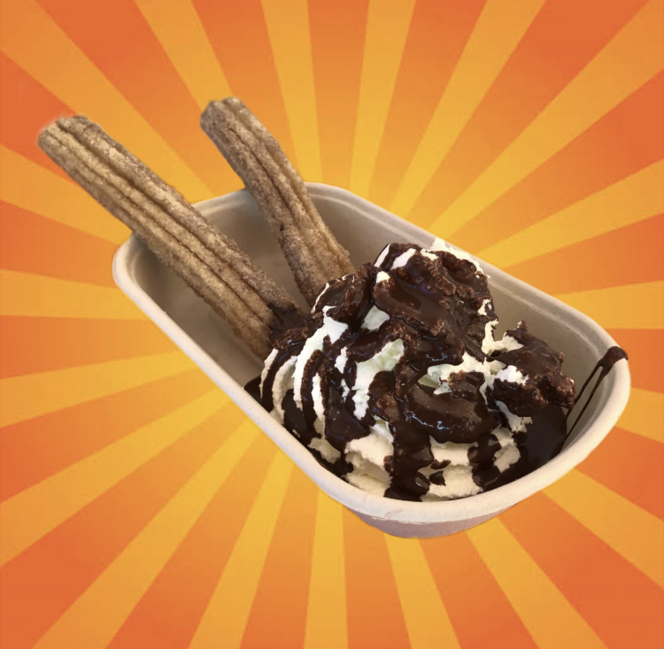

**Churro with fresh cream and your choice of sauce**

**$9**